# Limitation of Axial Mapping and Methods to make a Breakthrough

**Theory of Architecture 2 paper work**

## Phase II Zhengyang Chen

**Keywords: Space Syntax, limitation, mapping, adjacency matrix 1 Background**

The past decades have seen the promoting of mapping and analysis method

dealing with architecture and urban problems, from descriptive Geometry to urban image of Kelvin Linch and nowadays we have multiple options of method that can describe the design problems and situations.

As a typical pioneer theory in recent days, space syntax theory proposed by Hillier. B. and a group of scholars were seen widely known and greatly propelled the application of new methods in both architectural and urban mapping.I am really grateful that I gain the opportunity to attend the architecture theory 2 and work with John as I heard Georgia Tech contributes a lot to perfecting the space syntax theory.

This passage’ s intention is to launch a discussion over the current limitation of the space analysis method by developing a new matrix-based method and making a comparison between current cognitive mapping and upgraded cognitive mapping experiments, and try to analysis the site located in the U.S. and China.

As neighborhood best describe the element unit of American cities, the experience in blocks divided by streets of importance should represent the American citizen life. Different from many auto-generated China cities through ages, the blocks by half-mile or a mile were distinct in planar view, and can be treated as a typical texture of city, while space syntax analysis and application may enhance the understanding of city life. It can also be quite directly perceived through senses while we refine and abstract the street arrangements into axial mapping in super block studies thanks to the relatively regular scales and the explicit boundary restrictions in superblocks, that is , it can be considered integrated circumstance and dispel the complexity of some other urban texture that may be difficult to figure out and lead to variety and instability of outcomes that may contribute to endless dispute.

Compared with the planned rectangular neighborhood blocks with explicit boundaries in the United States, typical Chinese city is rather randomly grown, geographical dependent with context complexity thanks to the long term developing and constant transformation of circumstances in Chinese history. In consequence, modern Chinese cities are of no outstanding regularity and its road conditions are of various. It is interesting to find out how well the space syntax method will act in this condition, how far it is from the real situation, and what limitation and potential it

may have.

By announcing a new description of city interactive structure, the discrete geometry model of city were provided, as the spatial problem may be discrete-that is , when we talk about the relationship of the space rather than the real experience or image of space, the elements, or saying ,the separated space, are connected not by a sensual or graphic parkways, avenues, walks-no matter what it exactly is- but a description of discrete model of graph. The axial map shall be treated as nodes and edges that forms a graph(A theory of the city as object: how spatial laws mediate the social construction of urban space, Hillier,2002).

A mathematical explanation of this theory can be given as followings. Graph belongs to a common type of data structure. And data structure is the summary of relationship between elements(Data Structure, Weiming Yan,2006). So the way how we describe the graph is :G=(V,E), in which V stands for vertex and E stands for edge, which can be conclude as a pair of vertex E=<v1,v2>. And the theory of graph in discrete mathematics(or combination mathematics) provide the basis for space syntax.

## Problem Statement

When we concentrate on the concept provided, it was really justified and theoretically correct, however in reality we may face challenges. Not only the topography can lead to possible solution, the real condition also can. For example, in the theory of space syntax, the streets were treat equal- that is , it describes the relationship, and the access to the surroundings also, but how does it make sense that the method used in urban analysis assert that all the streets are in the same condition- in other words, why should an axial/segment map rely on an assembly of lines?

Theoretically there’s no doubt that we can transfer the street in a description of line that they both have the linear attribute and, both of them perfectly described the relationship between nodes in the block and other segment of streets. But if we rethink over it reversely - can a simple line tell everything of a street? Can we tell that if this is a rapid road with 12 lanes, or a quiet parkway with pedestrian walks? Actually no. But both a rapid road and a parkway can be transformed into a line that describe the relationship.So mathematically this method is a sufficient but unnecessary condition.

Thus based on this doubt we can ask endless questions like: Can the current mapping tools of space syntax tell if the street has no pedestrian walk, or the street was equipped with additional elements- skywalks for example- what will the space syntax concern act? What if it is a rapid way with sidewalk but no pedestrian crossing, and the two sides of the street were considered non-connective? What if the street is pedestrian only? What if the street happens to be an exit of rapid transit? What if it is a tramway?

So as an iteration, the limitation of the current space syntax mapping and visualization method is that it cannot tell the difference of the streets to explain real condition of the street network.

Thus in this passage I tried a method based on the current theory, note that this development sent no rivals to the space syntax theory, but is an addition to the current

mapping method. To avoid being too abstract, in this paper we deal with two practical problems - The direction of the street and the car flow at the intersection of the street.

To be more detailed, the first problem this method is to solve is to tell the difference of space syntax mapping when some of the streets in the network are one-way. The second task is to deal with the street intersections with limits/permissions on left/right turns, and see how it may contribute to the general mapping visualization outcome.

## Current Method on Urban Space Syntax Analysis

Mapping method of Space Syntax has the limitation, while I am not saying the theory itself is wrong, but the current method of mapping is based on geometries of line segments. When we transform that into visualization by mapping it into Convex/Axial/Segment, we suffer a loss of street information.That is, we cannot tell differences between these streets.To be more detailed, when we draw a line in a software whatever, we have the emotion and intention to convey our understanding of street, blocks, etc. We know that this is a main street, this is a pedestrian-friendly street... But for a computer, what it will do is just only read in one line as a geometry, and make a place in memory to store it.

When we either let software computing the axial map from a base dxf drawing, or draw the line ourselves, can we say anything about the direction of the street, in order to analyse the car flow? Even though we finally achieved it by draw all street into separate lines, it is still hard to complete everything, for example, how can we describe the most simple intersection- A crossing?

But not that the drawing in lines are entirely wrong, the limitation is all because the computer cannot understand the difference between the lines.Thus we can make further assumption - if we can have a method to describe the real condition, like one-way streets and left/right restriction at the crossing, and let computer understand the step, we can develop an advanced version of mapping.

## Matrix Based Mapping - An Approach on Analysis and Cognitive Mapping

In fields of mathematics and computer science, it is always a good thing to have the sense to transform relationship(Data Structure/Mapping/Equations) into matrix, a simple and common matrix have two dimensions, and it can help to define the value between two coordinates that form a relationship

We know every 2-dimension linear item has 2 normal directions , so does a street. for a street AB, it has 2 directions of A,B and B,A.

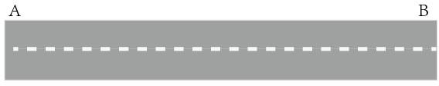⬆0 *x*

⬇ 

*y*

0

 ✗

x and y can be a variable that describe the condition of the street, it can be the length, the amount of street side shops, or even the amount of well-armed 23year old

recently retired soldier driving from one point to another. We just consider that x, y is a parameter, that means the interaction between A and B exists and use C(constant) to describe them in total.

For the typical method for space syntax mapping , the value in the matrix can be concluded into 3 categories - 0, MAX, C.

0 means self, in further calculation we ignore this because for space syntax mapping it makes no sense to argue the relationship between Street Alpha and Street Alpha(Some Architects and Philosophers may do), and it may also cause severe problem/fatal error in computational( iteration over no ending condition

MAX means infinite, in mathematics we have the symbol of to describe a value that is large enough(beyond our imagination), and for this typical matrix, a MAX can be a self-defined value, which means no relationship or the relationship in special condition should not count. and in calculation as well as computing, we always place a conditional statement in order to omit the process( if n< MAX)

C as a constant , is used to describe the existing relationship, when we meet a constant, we should have the sense that there' s relationship between the related two coordinates.

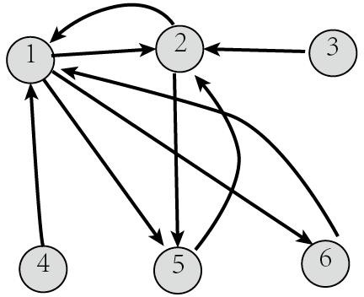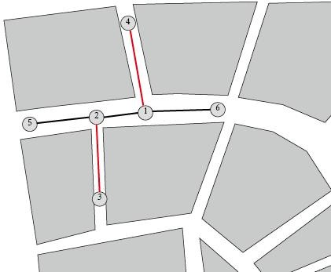

## Describe Restriction in Matrix

Now let’s do 2 exercises, one is to describe one way street in matrix, and another is to describe restriction on turning.

Firstly, the one way street, given two restrictions on street<2,3> and <4,1>, only the direction from 4 to 1 and from 3 to 2 is permitted, thus we can describe them in matrix: <1,4>=C; <4,1>=MAX; <3,2>=C;

<2,3>=MAX. So the adjacent matrix in this case is done.

Then let’s do another, the left and right turn:

In this case we describe how we deal with intersection between streets, we take a simpliest crossing with some restriction on turns.A is a left turn only street, and D is right turn only, thus It can be described as

0

*C*

*Max C*

*Max*

*C Max Max Max Max*

*C* 0 *C*

*Max C*

*Max Max* 0

*Max Max*

*Max Max Max* 0

*Max*

*C C*

*Max Max* 0

*C*

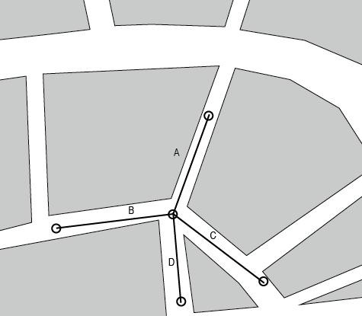*Max Max Max Max* 0

<A,B>=MAX;

<D,B>=MAX

So the matrix will be:

0 *C*

*C* 0

*C C*

*C Max*

*Max C*

*C C*

0 *C*

*C* 0

Some may place doubt on it: in the first case we

describe the streets in nodes 1,2,3... In the second case we describe the streets in lines A, B,C...

To answer this question we can make theoretical explanation:the Graph is constructed by Vertex and Edge, and Edge can be described as a pair of Vertex.Thus, G=(V,E) and E=<v1,v2> .In the first case the vertices are intersections, and in the second case the vertices are lines.So they are all in the same tongue.

For example, let’s take a look back to the second case, if we make the restriction condition that street A is one way downwards.Thus the matrix can be described as:

<A,B>=C,<A,C>=C,<A,D>=C,<B,A>=MAX,<C,A>=MAX,<D,A>=MAX.

It’s obvious that it is also correct definition of one-way street.

## Prototype testing

Let’s see a simple case of matrix based mapping visualization.

To test and realize the assumption I write a piece of code in Iron Python that can randomly generate an assembly of lines as a fake street network, and then randomly place the restriction of left-turn and right-turn as well as one way situation. By using rhino tools we can make the visualization process. We use dijkstra algorithm to realize the path finding and calculate the average depth.In this case we are showing result of connectivity and integration.

Based on the description in Matrix we can append matrix into lines.To simply realize that we can open a Rhino file, and generate the street networks.

In this case, the first step is to create 4 layers: DEFAULT, LEFT, RIGHT,and ONEWAY. Put the street network into the DEFAULT layer, if there’s a restriction at the corner, mark a segment and put them into LEFT/RIGHT/ONEWAY layer.Notice that the one-way mark should be as the real direction accordingly.

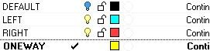Press the ‘Reset engine and debug’ to run the code and the outcome changed while the restriction changed.

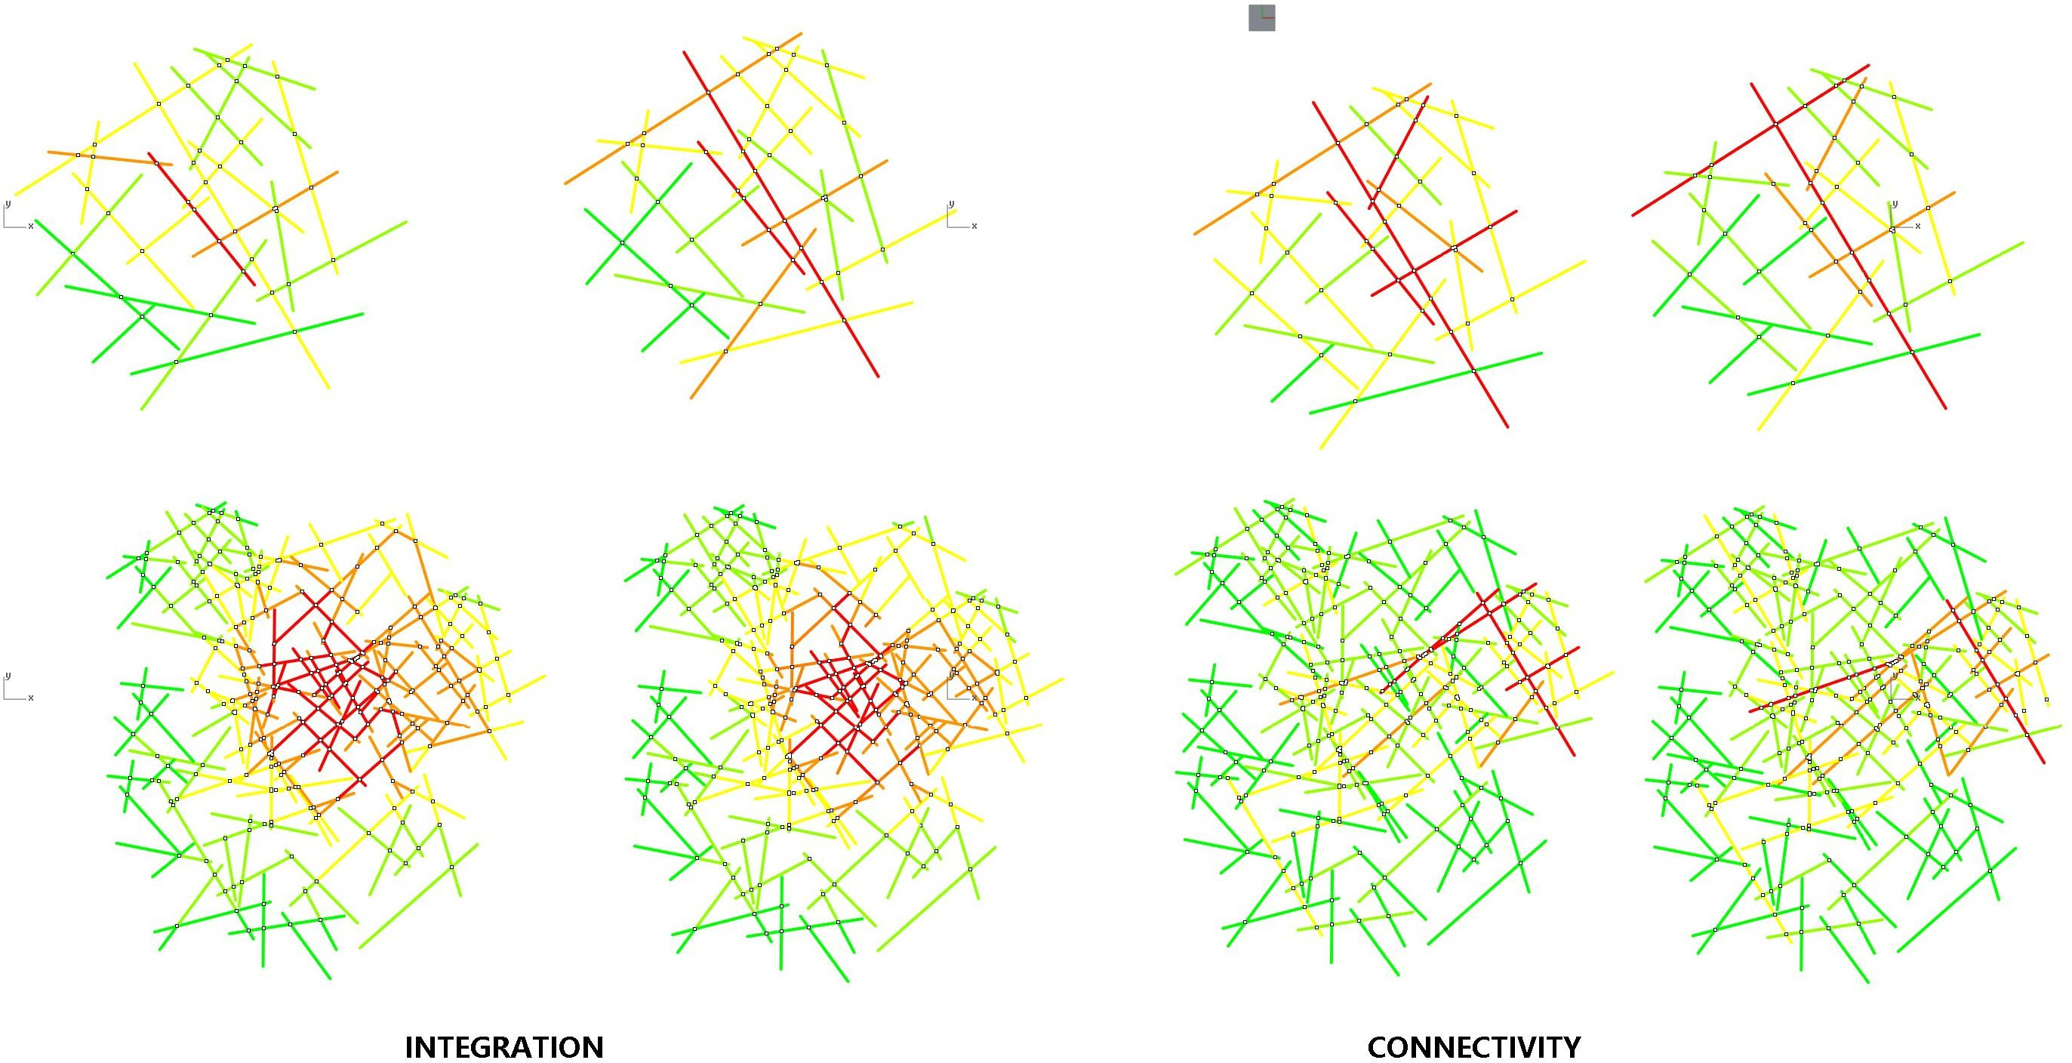

To make further discussion, I choose one real site to do the analysis

## Application - Analysis of Superblock-sized (1 mile* 1 mile) Urban Area.

In this case let us see a 1 mile * 1 mile block in China,The site is located at North Bund area,Yangpu District, Shanghai, and is a relic of old industrial zone.In this area there’ s building clusters aging from 1900s to 2000s, thanks to the complexity of block types and ages, and in consequence the hardness of regional planning, the traffic was under various of restrictions to relief the heavy load of traffic in such dense city of 24 million population.

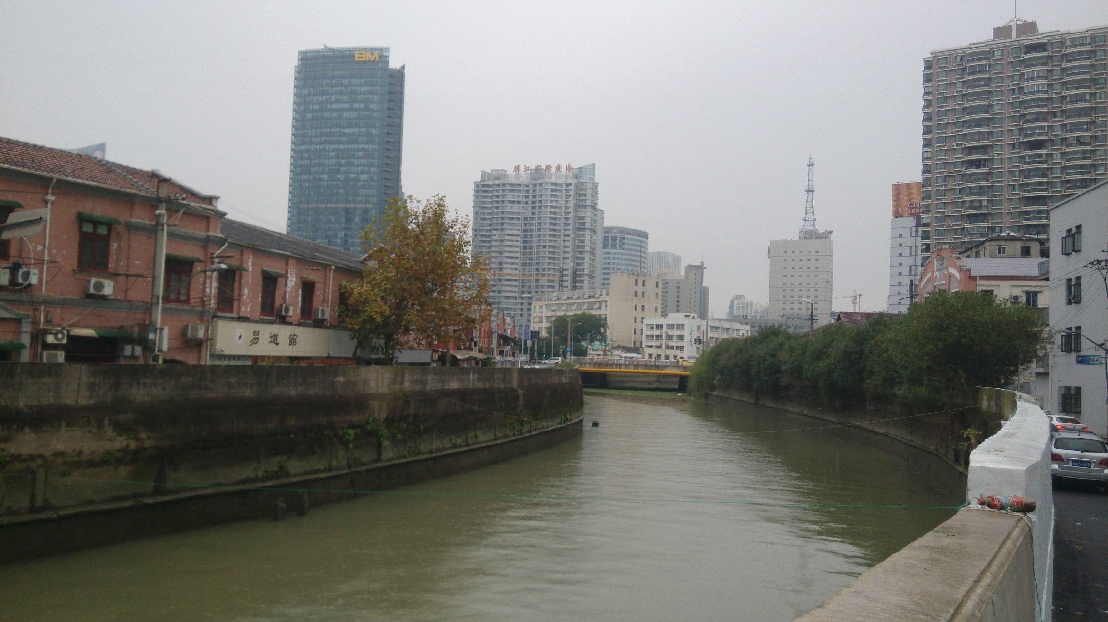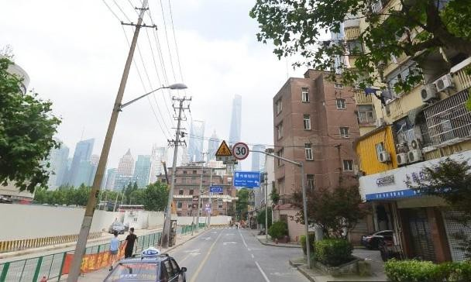If we take a glance at the site, we can see typically poor planned road compared to the average condition of road in Yangpu district. The following pics showed the historical river of Hongkou that go through the district with two one-way drive road at the riverside.

Site snapshots

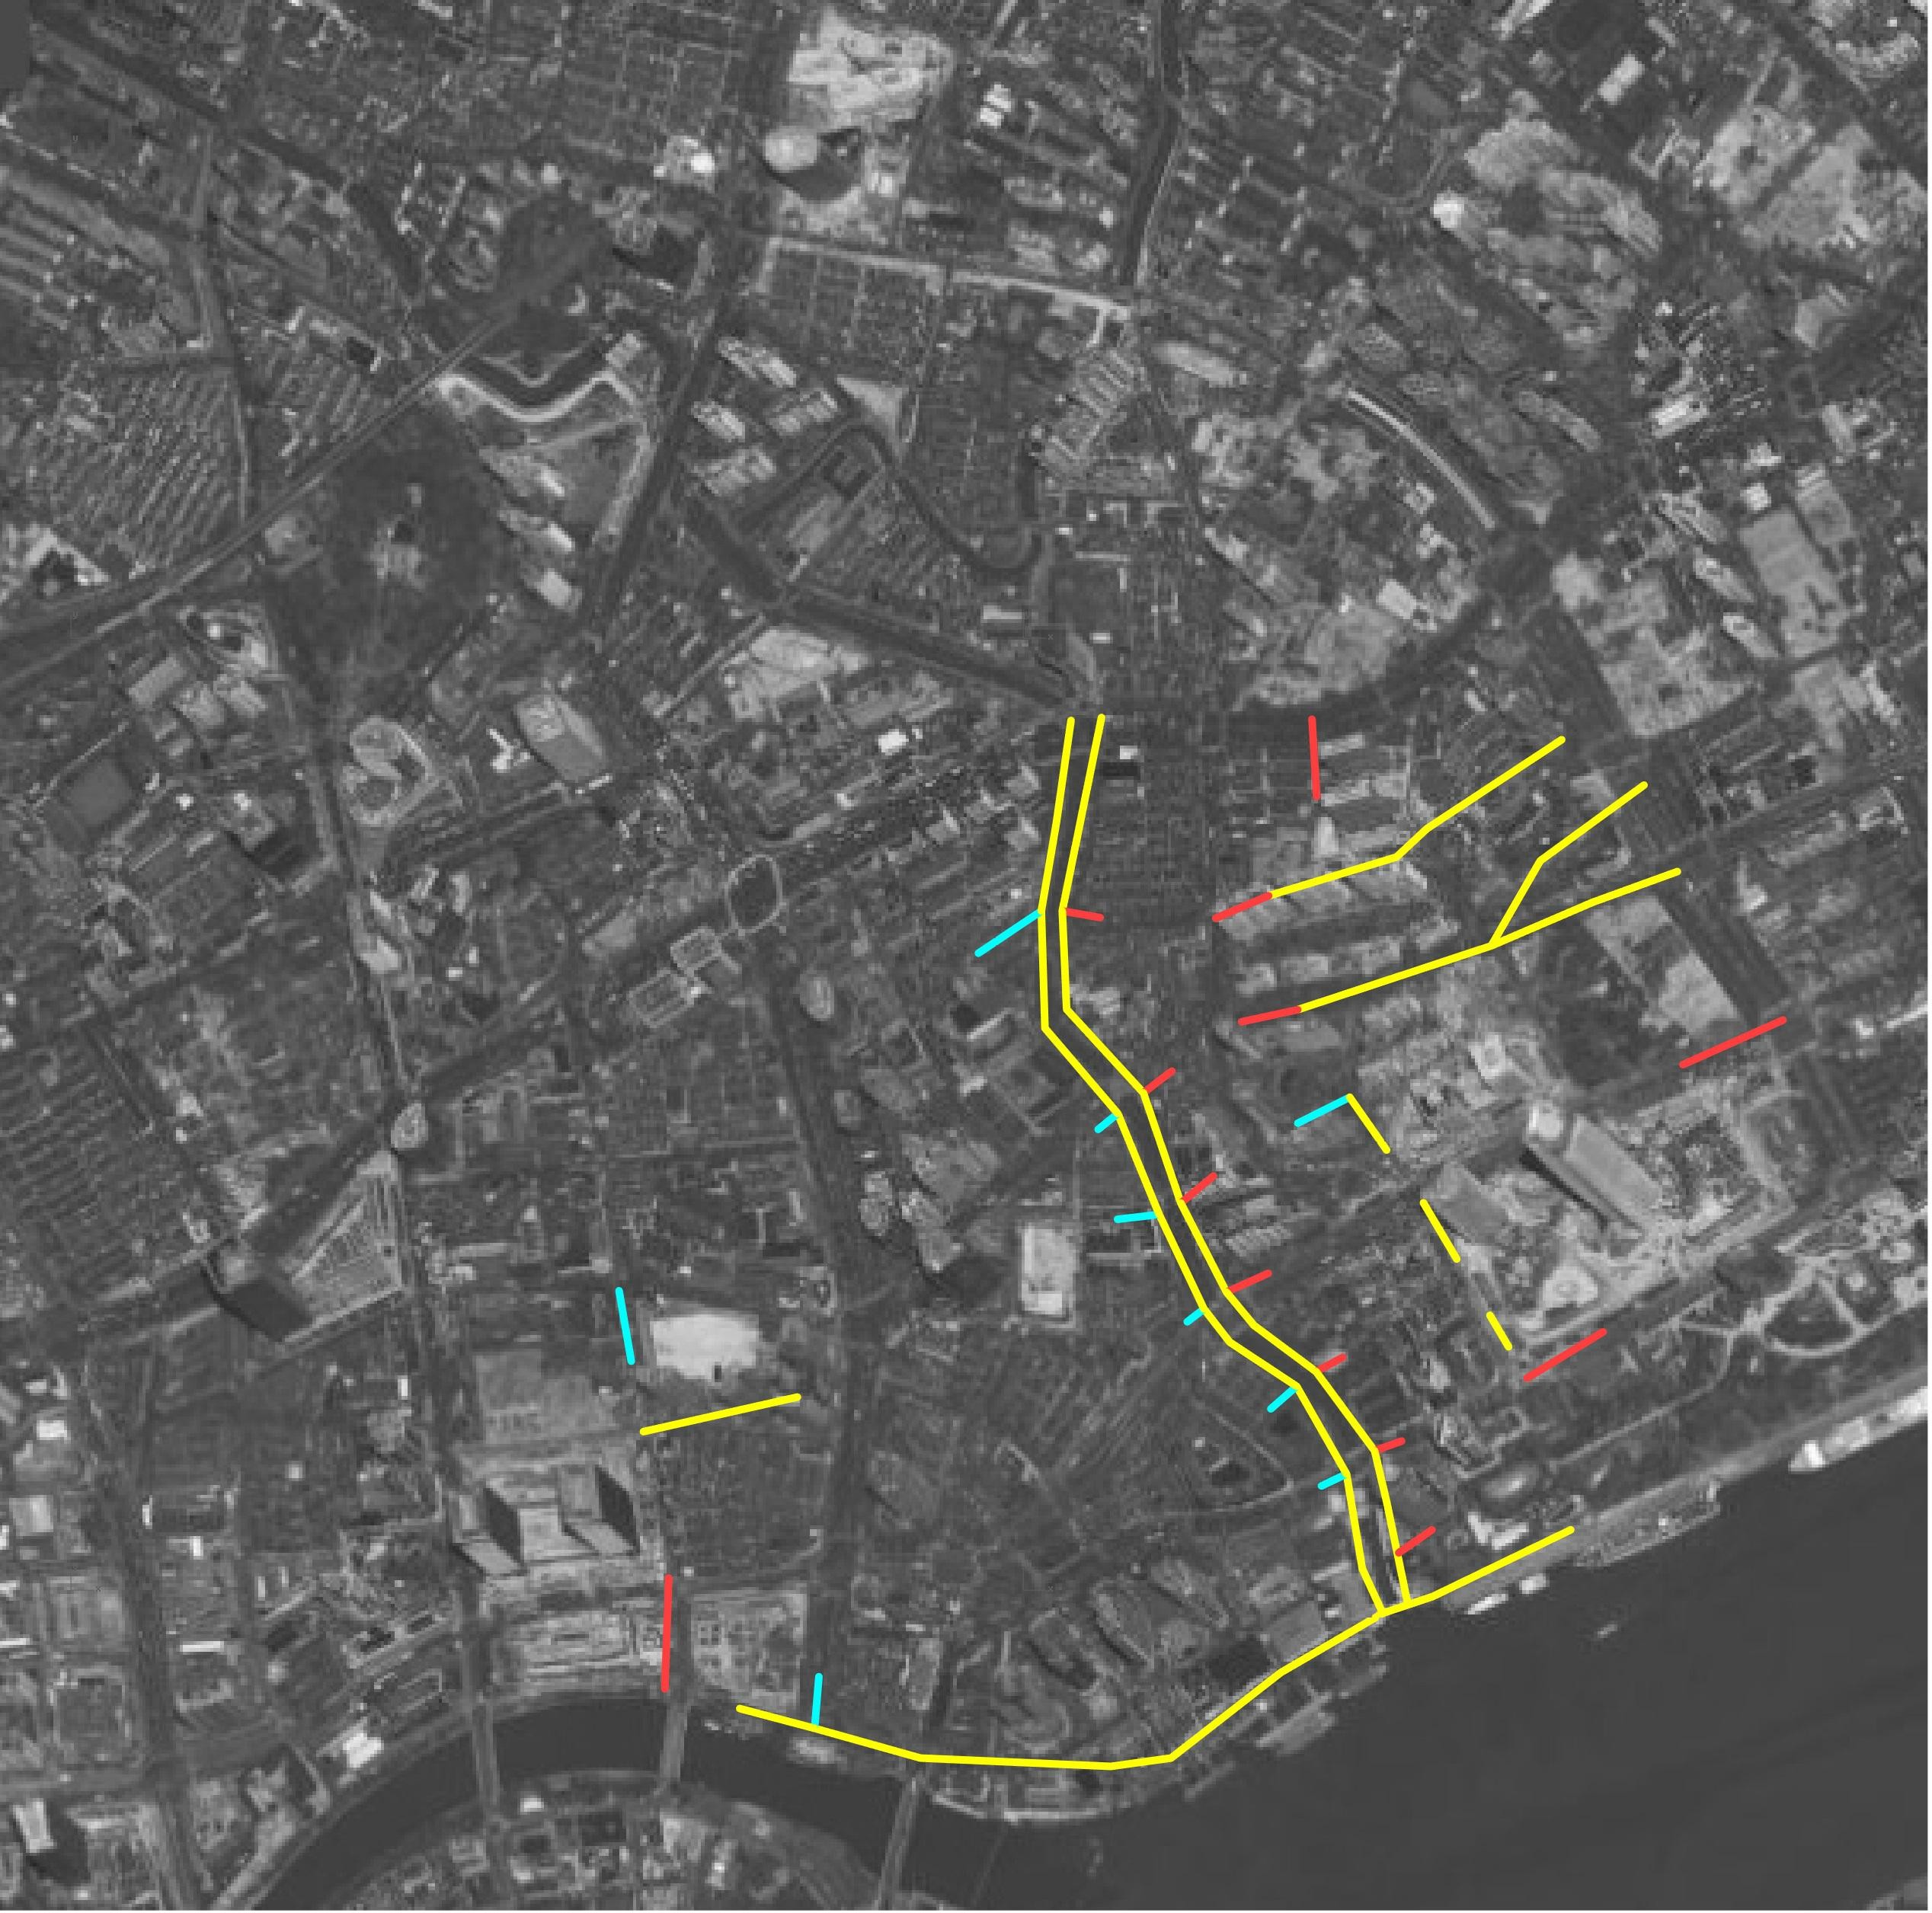Then let me show the restrictions in a site plan.

restrictions condition marks:one way(yellow),right only(red),left only(blue)

The first comparison is the connectivity, if we use visualization method based on current mapping technique we can see the result as left.And if we place restriction, the outcome changed.

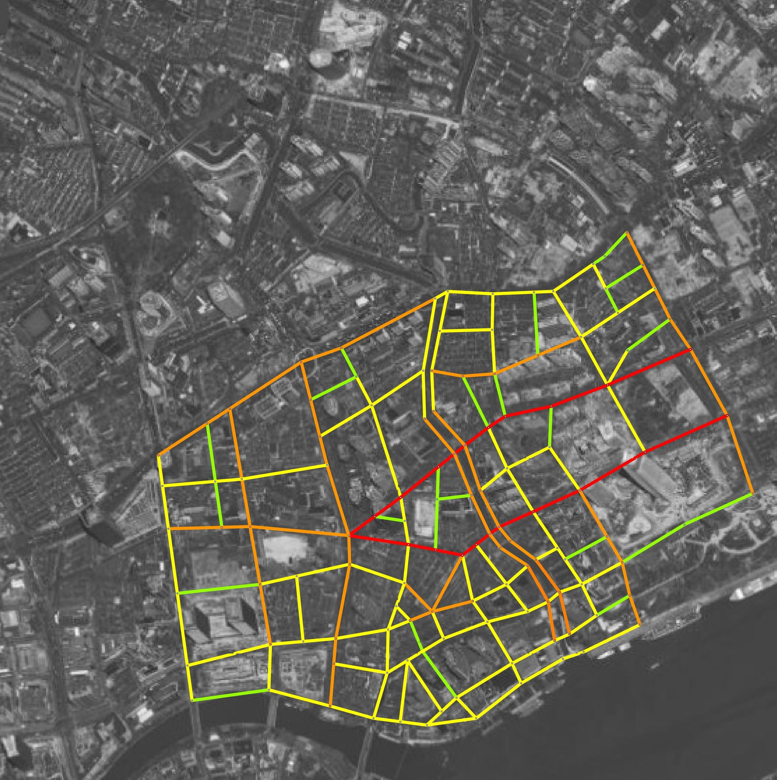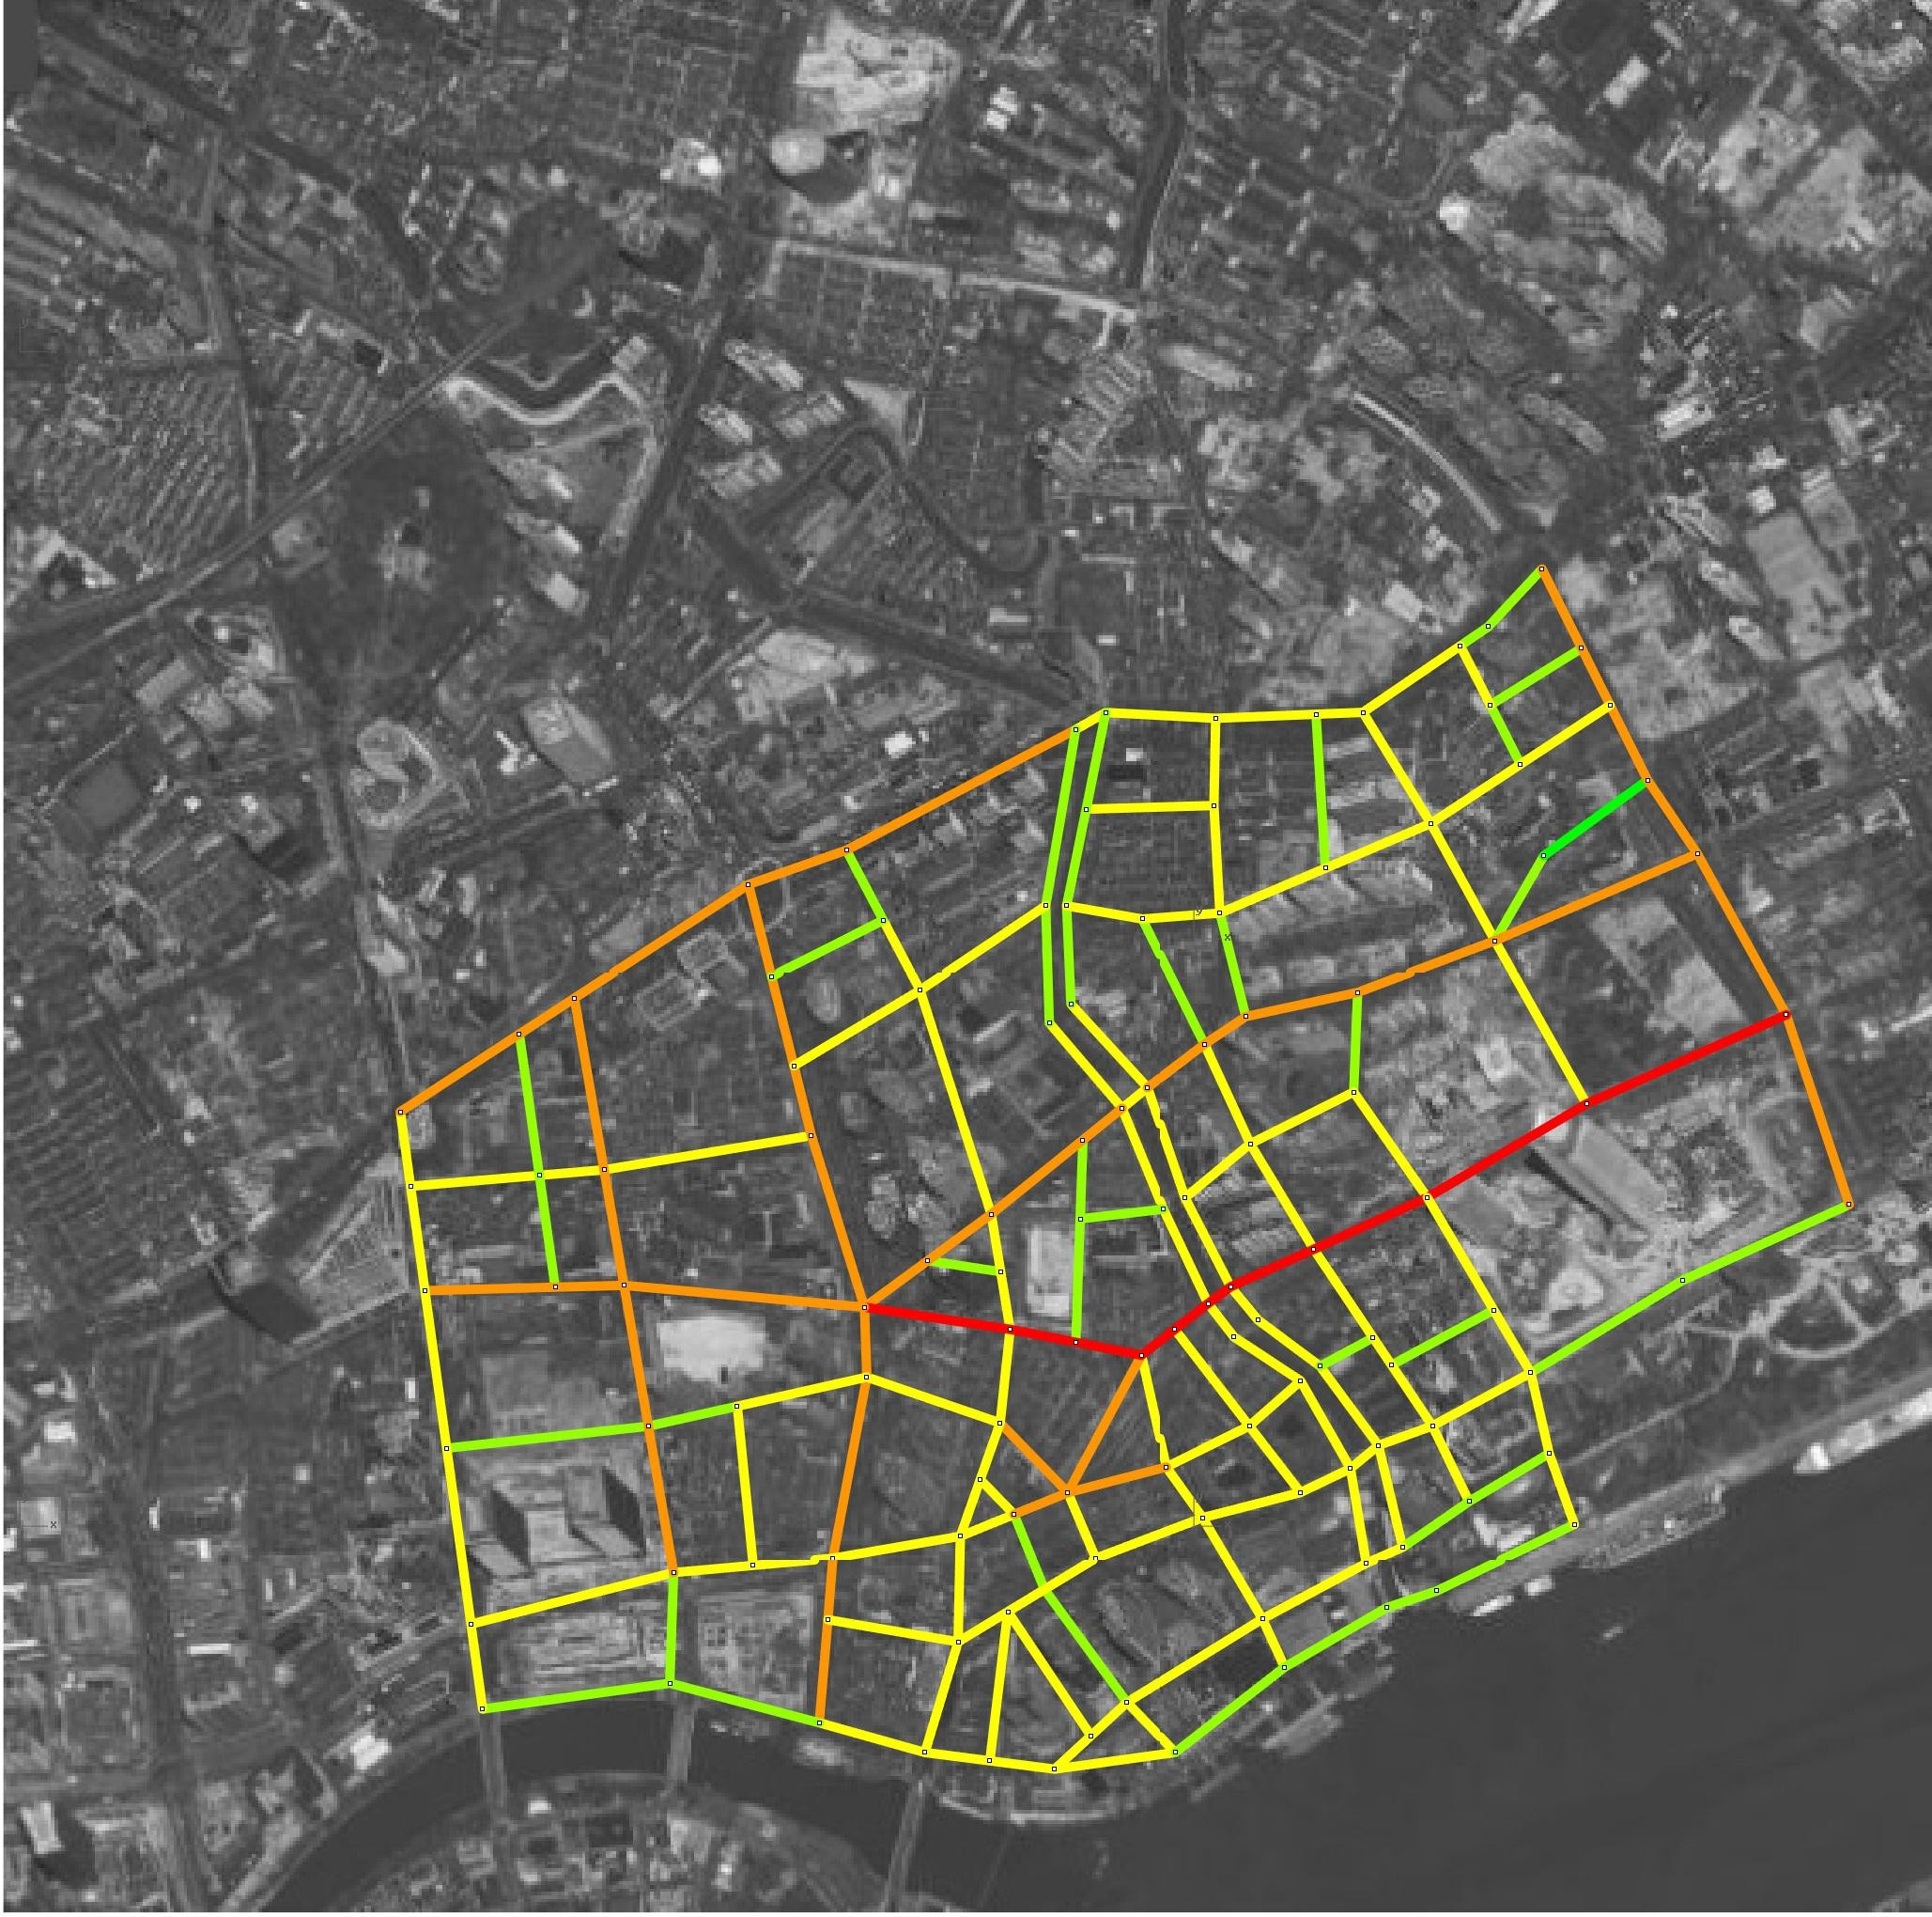

Connectivity(None-Restrict) Connectivity(Restrict)

So we can see from the result that the connectivity changed rather sharply in the middle two paralleled one-way streets and the upper west-east channel, Go back to the restriction condition we can analyse the result: the dense one-way restriction both on itself and the streets it meets contributes lot on the loss of connectivity at the west-east channel. And for the middle two paralleled walk, they not only suffers the one-way restrict on themselves, but also the strict left/right restriction at entrance(Actually they acts quite the same).

Then let’s see the integration:

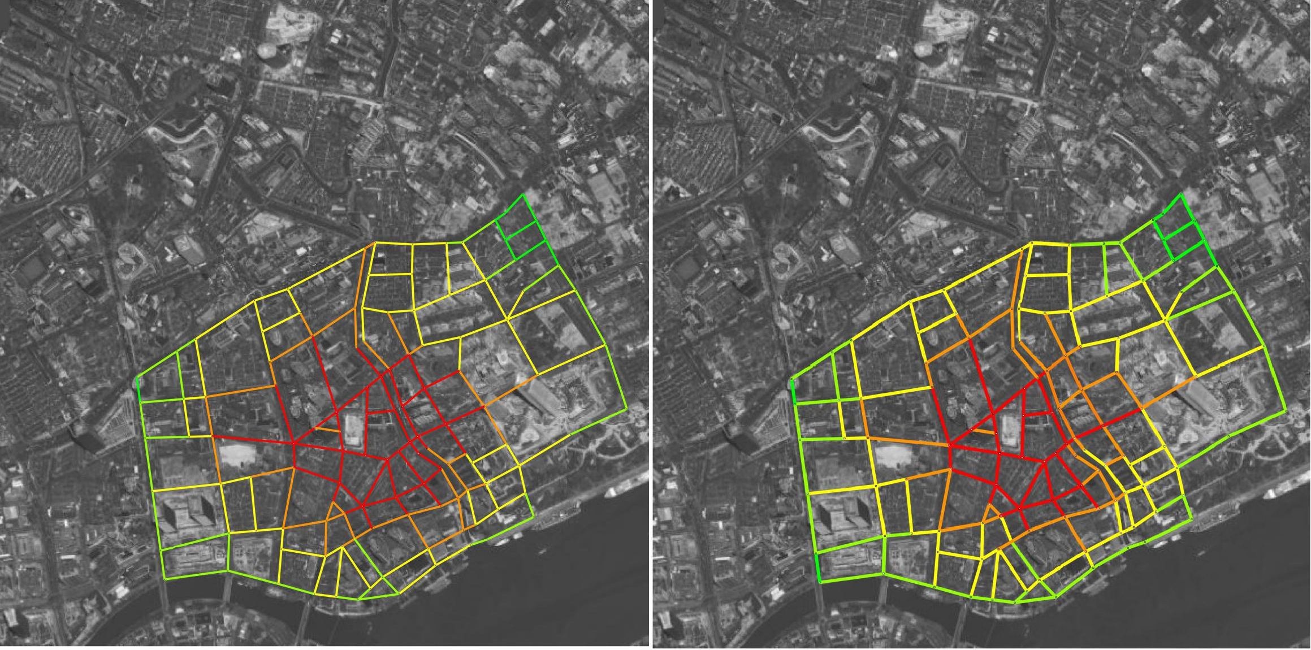

Integration(None-Restrict) Integration(Restrict)

The integration overview is quite the same and has merely changed after restriction placed.But If we take a detail look, we can see the Restricted result has a

tiny shift of the integration zone to the left side,and the Right part of the red zone is squeezed a little bit. When we look back to the restriction mapping, we can see that the restrictions are dense in the middle and north east part of the area, Thus the steps to reach the related street segments should be more. And the Average depth from the dense restriction zone is actually more. It can be easy to understand if a driver were trapped in an area with left/right/one way restriction everywhere, there’s more possibility for him to take more efforts to other streets.

## Conclusion

The space syntax theory is powerful that can act as a cognitive mapping method and helped us to develop the mind that analysis the image of the city. Based on graph theory, the space syntax is that forward looking that can even perform well at the age of 1970s, when computation method did not spread into every field as nowadays.It focus on the inner link of spaces rather than concrete dimensions of the street, thus it can display on a specific scope of space relationship.

However the limitation comes because it can not tell the differences of input data and. When we attached the method of adjacent matrix behind the input data, we can see from the output that the restriction of the traffic did played a role in the mapping process.

If we replace the street by adding one-way restriction into it, it will react accordingly.In this case the connectivity change will be the most explicit outcome and it is easy to understand, that connectivity calculates the amount of adjacent or linked street elements thus it operates only on the child of each node, and only affects the first layer from the origin.That is, in other words, a result based on single depth.Compared with the connectivity, the integration result are slightly different from what the non-restriction case come out. In this case we can see that the red zone that represents the high integration shifts a little bit left. And it is also easy to understand that the northeast and central part of dense restriction on traffic are responsible.The mere in change also stands for the robust of the street network, if one path of defining the depth from one element of another was blocked due to the restriction placed on the road, we can depend on the network to find a second choice, and the average depth was based on the statistical summary of the network path-finding, thus only the large amount of restrictions placed in certain limited area will come up with an explicit different result.